Pitching Performance and
Wins in Major League Baseball
Data Assignment #1: Data Summary and Data Display

Anthony Picheca
Student #: 1011178930
Course: MGEB11 Quantitative Methods in Economics I
Instructor: Laura Turner
Date: October 3, 2025

Introduction
The PitchingMLB dataset holds information on Major League Baseball starting pitchers, including their total number of wins and losses, strikeouts per inning, home runs allowed per inning, and runs allowed per inning. A significant component of a major league sports team’s success is the analysis that takes place behind the scenes. Understanding the relationship between these statistics and a pitcher’s number of wins provides valuable insight into which performance indicators are most closely tied to effectiveness on the mound.
This report focuses on two key relationships: the relationship between strikeouts per inning and wins, and the relationship between runs allowed per inning and wins. My goal is to determine whether offensive dominance or defensive control is more closely linked to a pitcher’s success.
I applied data management techniques from Chapters 2 and 3, and by navigating Excel to provide numerical summaries, tables, and graphical displays such as histograms and scatterplots, I have simplified the data into a neat and presentable data report. The report begins with an overview of the dataset and descriptive statistics for each variable, followed by visualizations that display the relationships between wins and the performance measures. Finally, the report concludes with a summary of my interpretation of the comparison between the two relationships and what the data suggests about pitcher success in Major League Baseball.
Data Description and Descriptive Statistics
Within the PitchingMLB dataset, performance statistics for 20 Major League Baseball pitchers are organized into a standard graph with the six quantitative variables mentioned earlier: wins, losses, ERA, strikeouts, home runs allowed, and runs allowed. In this data summary, I will only be focusing on Wins, Strikeouts per Inning, and Runs Allowed per Inning, as they are the only relevant variables to the overarching question at hand.
The number of wins in the data set ranges from 8 to 24, with a noticeable right skew. On average, pitchers record 12.95 wins in the regular season, while the most successful pitcher, Justin Verlander, stands as an outlier with 24 regular-season wins.
The number of strikeouts per inning varies from 0.46 to 1.01 with a relatively normal distribution. On average, pitchers record 0.78 strikeouts per inning pitched with no noticeable outliers, as the data distribution is normal.
Lastly, the number of runs allowed per inning spans from 0.29 to 0.57, a much tighter data spread than the other two important variables. There is a bimodal distribution of this data, with the bulk of pitchers recording between 0.39 and 0.44 or between 0.49 and 0.54, and the average pitcher allowing 0.45 runs per inning pitched.
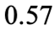
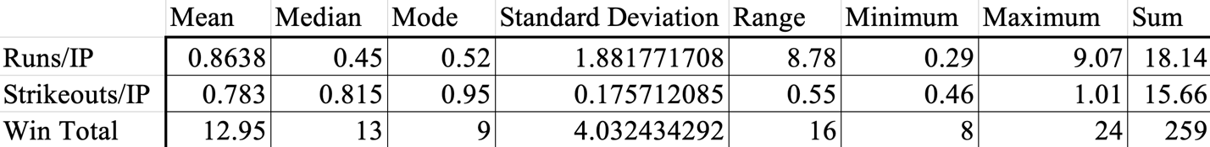

Graphical Displays – Strikeouts per Inning Pitched

Figure 1: Distribution of Strikeouts per Inning Pitched
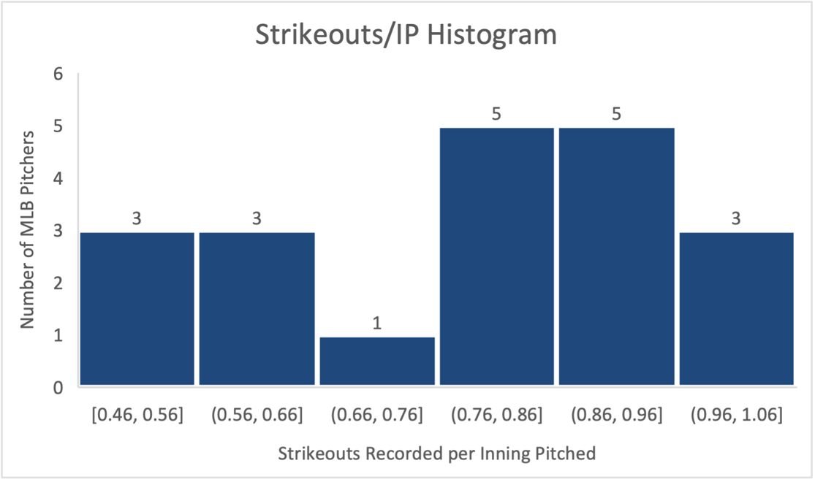

Figure 2: Model of Strikeouts per Inning Pitched vs Wins
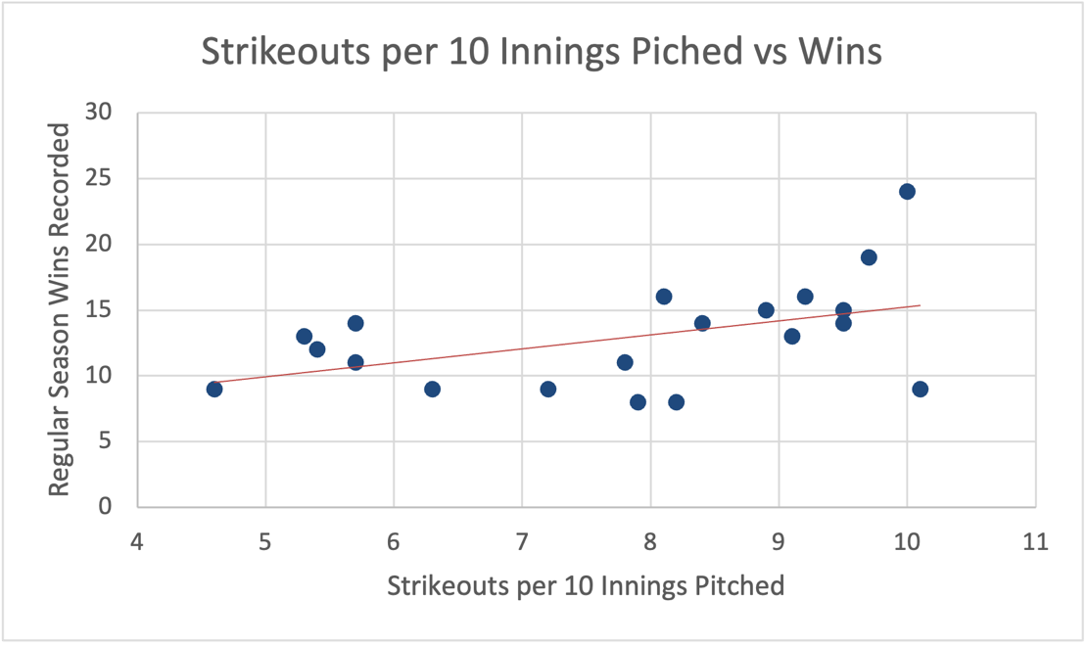
Discussion
The histogram above (Figure 1) shows the distribution of strikeout rates among the 20 pitchers in the sample. The scatterplot (Figure 2) demonstrates that there is a positive relationship between a pitcher’s strikeout rate and their total wins.
Graphical Displays – Runs Allowed per Inning

Figure 3: Distribution of Runs Allowed per Inning Pitched
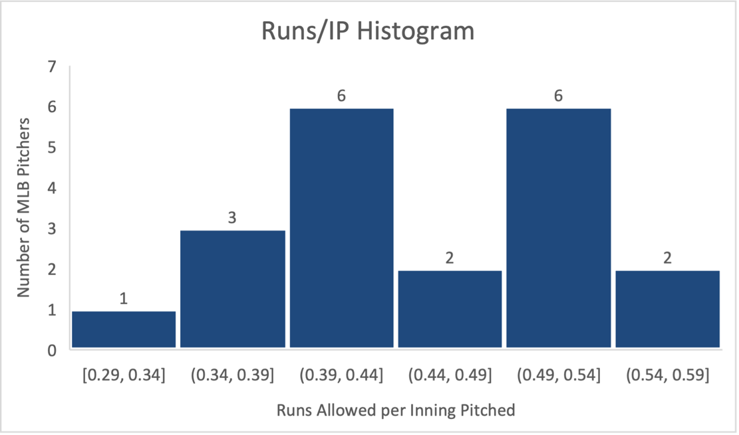

Figure 4: Model of Runs Allowed per Inning Pitched vs Wins
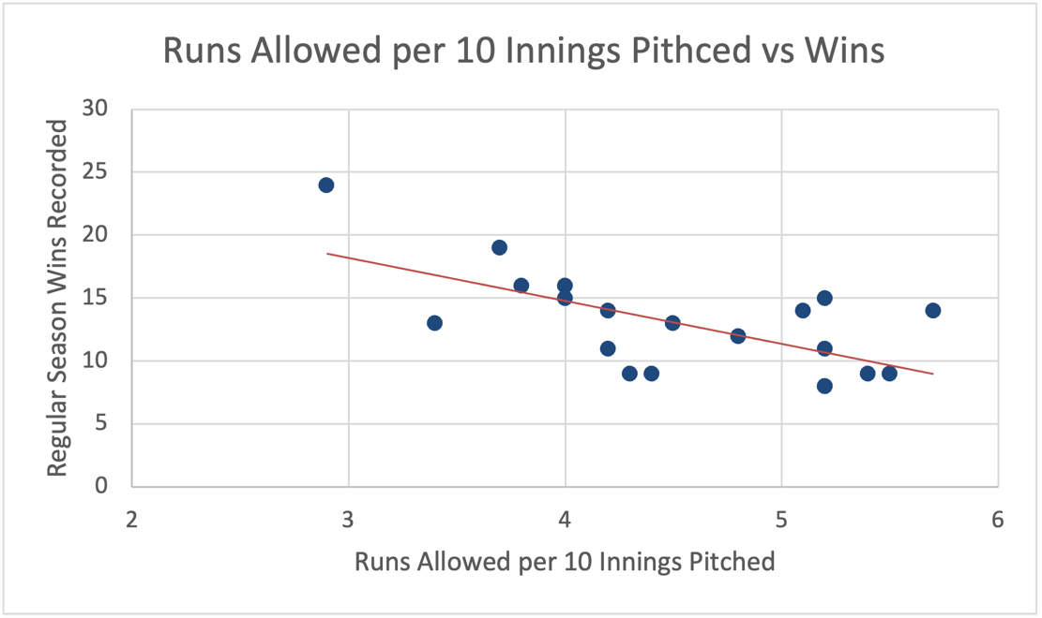
Discussion
The histogram above (Figure 3) shows the distribution of strikeout rates among the 20 pitchers in the sample. The scatterplot (Figure 4) demonstrates that there is a negative relationship between the number of runs allowed per inning and the pitcher’s total wins.
Table of Data
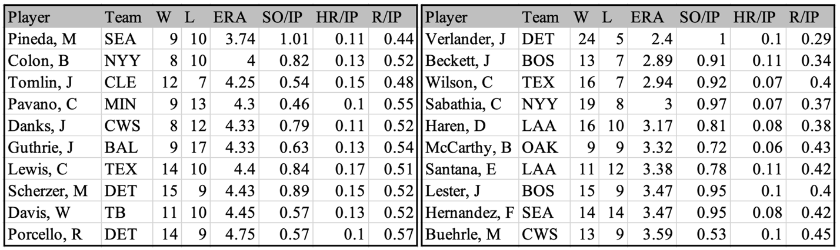
Comparison and Discussion
The data displayed in the graphs and charts above indicate a clear positive relationship between strikeouts recorded per inning and wins, while conversely, a clear negative relationship between the number of runs allowed per inning and wins. Generally, this was a very foreseeable relationship with regard to both variables; however, one element that does stand out is the difference in magnitude between these relationships.
Comparing specifically the strength of these two relationships, there is a stronger relationship between runs allowed per inning pitched and wins. From the purely visual side of things, the points on the “Runs Allowed per 10 Innings Pitched” scatter plot(Figure 4) are arranged much more tightly to their line of best fit than the points on the “Strikeouts per 10 Innings Pitched” scatter plot(Figure 2). However, as this course discusses quantitative methods in economics, the visual display is insufficient. From a purely mathematical perspective, these results are confirmed through the calculation of each relationship’s Multiple R Value. After applying elementary operations in Excel, I found the correlation coefficient between Runs Allowed and Wins to be approximately 0.6537, compared to the coefficient for Strikeouts per Inning and Wins, which was approximately 0.4652. This indicates that in Figure 4, the points on the scatter plot are about 20% more tightly packed together compared to the points in Figure 2.
Intuitively, this pattern makes sense in the context of baseball performance. Even if you have a pitcher with a generally subpar strikeout rate, they can still succeed because they have a full team of defenders behind them as a safety net. On the other hand, a higher rate of runs scored could only be compensated for by the pitcher himself being on a strong offensive team, which, as someone who has played baseball his whole life, I can tell you is not a very consistent plan. Furthermore, the strikeouts per inning metric is representative of a pitcher’s ability to control the game, whereas the runs allowed metric represents the entire team’s performance, which overall will reflect itself in the win total much more. Thus, by descriptive statistical analysis and through my general understanding of the game of baseball, it is evident that a team’s strong defensive prowess will always be a more reliable asset than a pitcher with a better strikeout rate.
Conclusion
This report monitored the relationship between both strikeouts per inning pitched and wins, and runs allowed per inning and wins. Descriptive analysis and Excel data manipulation showed the average number of wins to be 12.95, ranging from 8 to 24 regular-season wins, depending on the pitcher. The correlation between Strikeouts per inning pitched and wins was approximately 0.4652, while the correlation between Runs per Inning pitched and wins was much higher at -0.6537. These values suggest that while both variables have an impact on a pitcher’s likelihood of winning, a pitcher’s odds of winning are much more greatly affected by the number of runs they allow per inning. This fact is verified when examining the Regression coefficient of each variable. As displayed in the “Regression Summaries” page in my Excel report (see attached Excel file), an increase of 0.1 additional runs allowed per inning will result in approximately 3.4 fewer wins. On the other hand, an increase of 0.1 more strikeouts per inning results in approximately 1.07 more wins on the season. Evidently, allowing one additional unit of runs per inning will have over three times as much of an effect on the pitcher’s win total as one additional unit of strikeouts per inning.
In practical terms, pitchers who record fewer runs in their appearance on the mound tend to achieve higher win totals, even if their strikeout rates aren’t entirely too impressive. For example, the pitcher with the lowest number of runs per inning, Justin Verlander, managed to achieve 24 wins, whereas the pitcher who recorded the most runs allowed per inning, Rick Porcello, only managed to record 14 wins. Conversely, strikeout rates did not have such a toll on win totals. For instance, the highest strikeout rate in the PitchingMLB data set was 1.01, recorded by Michael Pineda, and the lowest strikeout rate among pitchers in the data set was 0.46, recorded by Carl Pavano. Both of these pitchers totalled exactly the same number of wins, showing that strikeout rate is a much less reliable metric for determining the overall success of a pitcher than their number of runs allowed per inning.
In summary, my objective was to determine whether there was a stronger relationship between strikeouts and wins or runs allowed and wins. Through my detailed analysis of the data, use of Excel’s data management functions, and my real-life understanding of the game of baseball, I was able to demonstrate that the number of runs allowed per inning is far more impactful on the outcome of the game than the starting pitcher’s strikeout rate.

Resources
- MGEB11 Quercus Excel File Download: pitchingmlb.xlsx
- MGEB11 Course Material
- MGEB11 Excel Tutorial One
- Statistics for Business and Economics, Cengage

